Morse KOB Sounder Driver Quick Start Guide

# Introduction:

The MorseKOB Sounder Driver is a simple circuit board to drive a real telegraph sounder from the popular freeware American (“Railroad”) Morse code practice utility: MorseKOB. MorseKOB may be obtained at <https://sites.google.com/site/morsekob/home?authuser=0>. I developed this board from a sample circuit on the MorseKOB site at <https://sites.google.com/site/morsekob/morsekob25/interface?authuser=0>.

The MorseKOB Sounder Driver is a compact board, about 2” x 2” that provides a single place to make all your connections: RS232 Dongle, Power and a Sounder.

Figure 1- MorseKOB Sounder Driver

With this board and a suitable “RS 232 Dongle” (note that Morse KOB is using an “off-label” application of the RS-232 RTS – “Request to Send” line and some RS232 adapters won’t work, I used a Sabrent CB-FTDI USB to Serial Cable Adapter. As of this writing it was available from a major on-line marketplace for <$15)

## Connections:

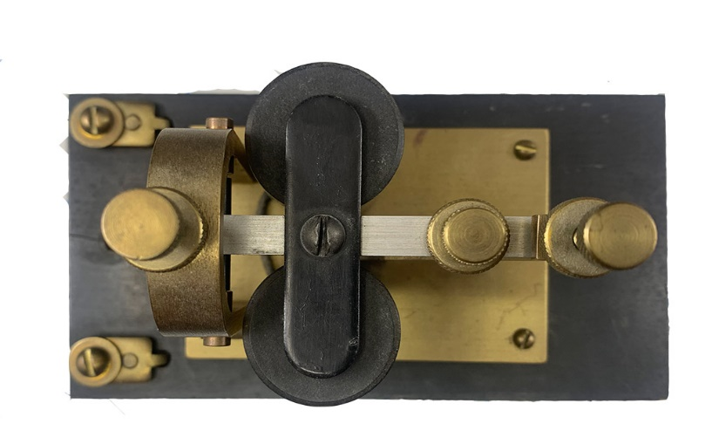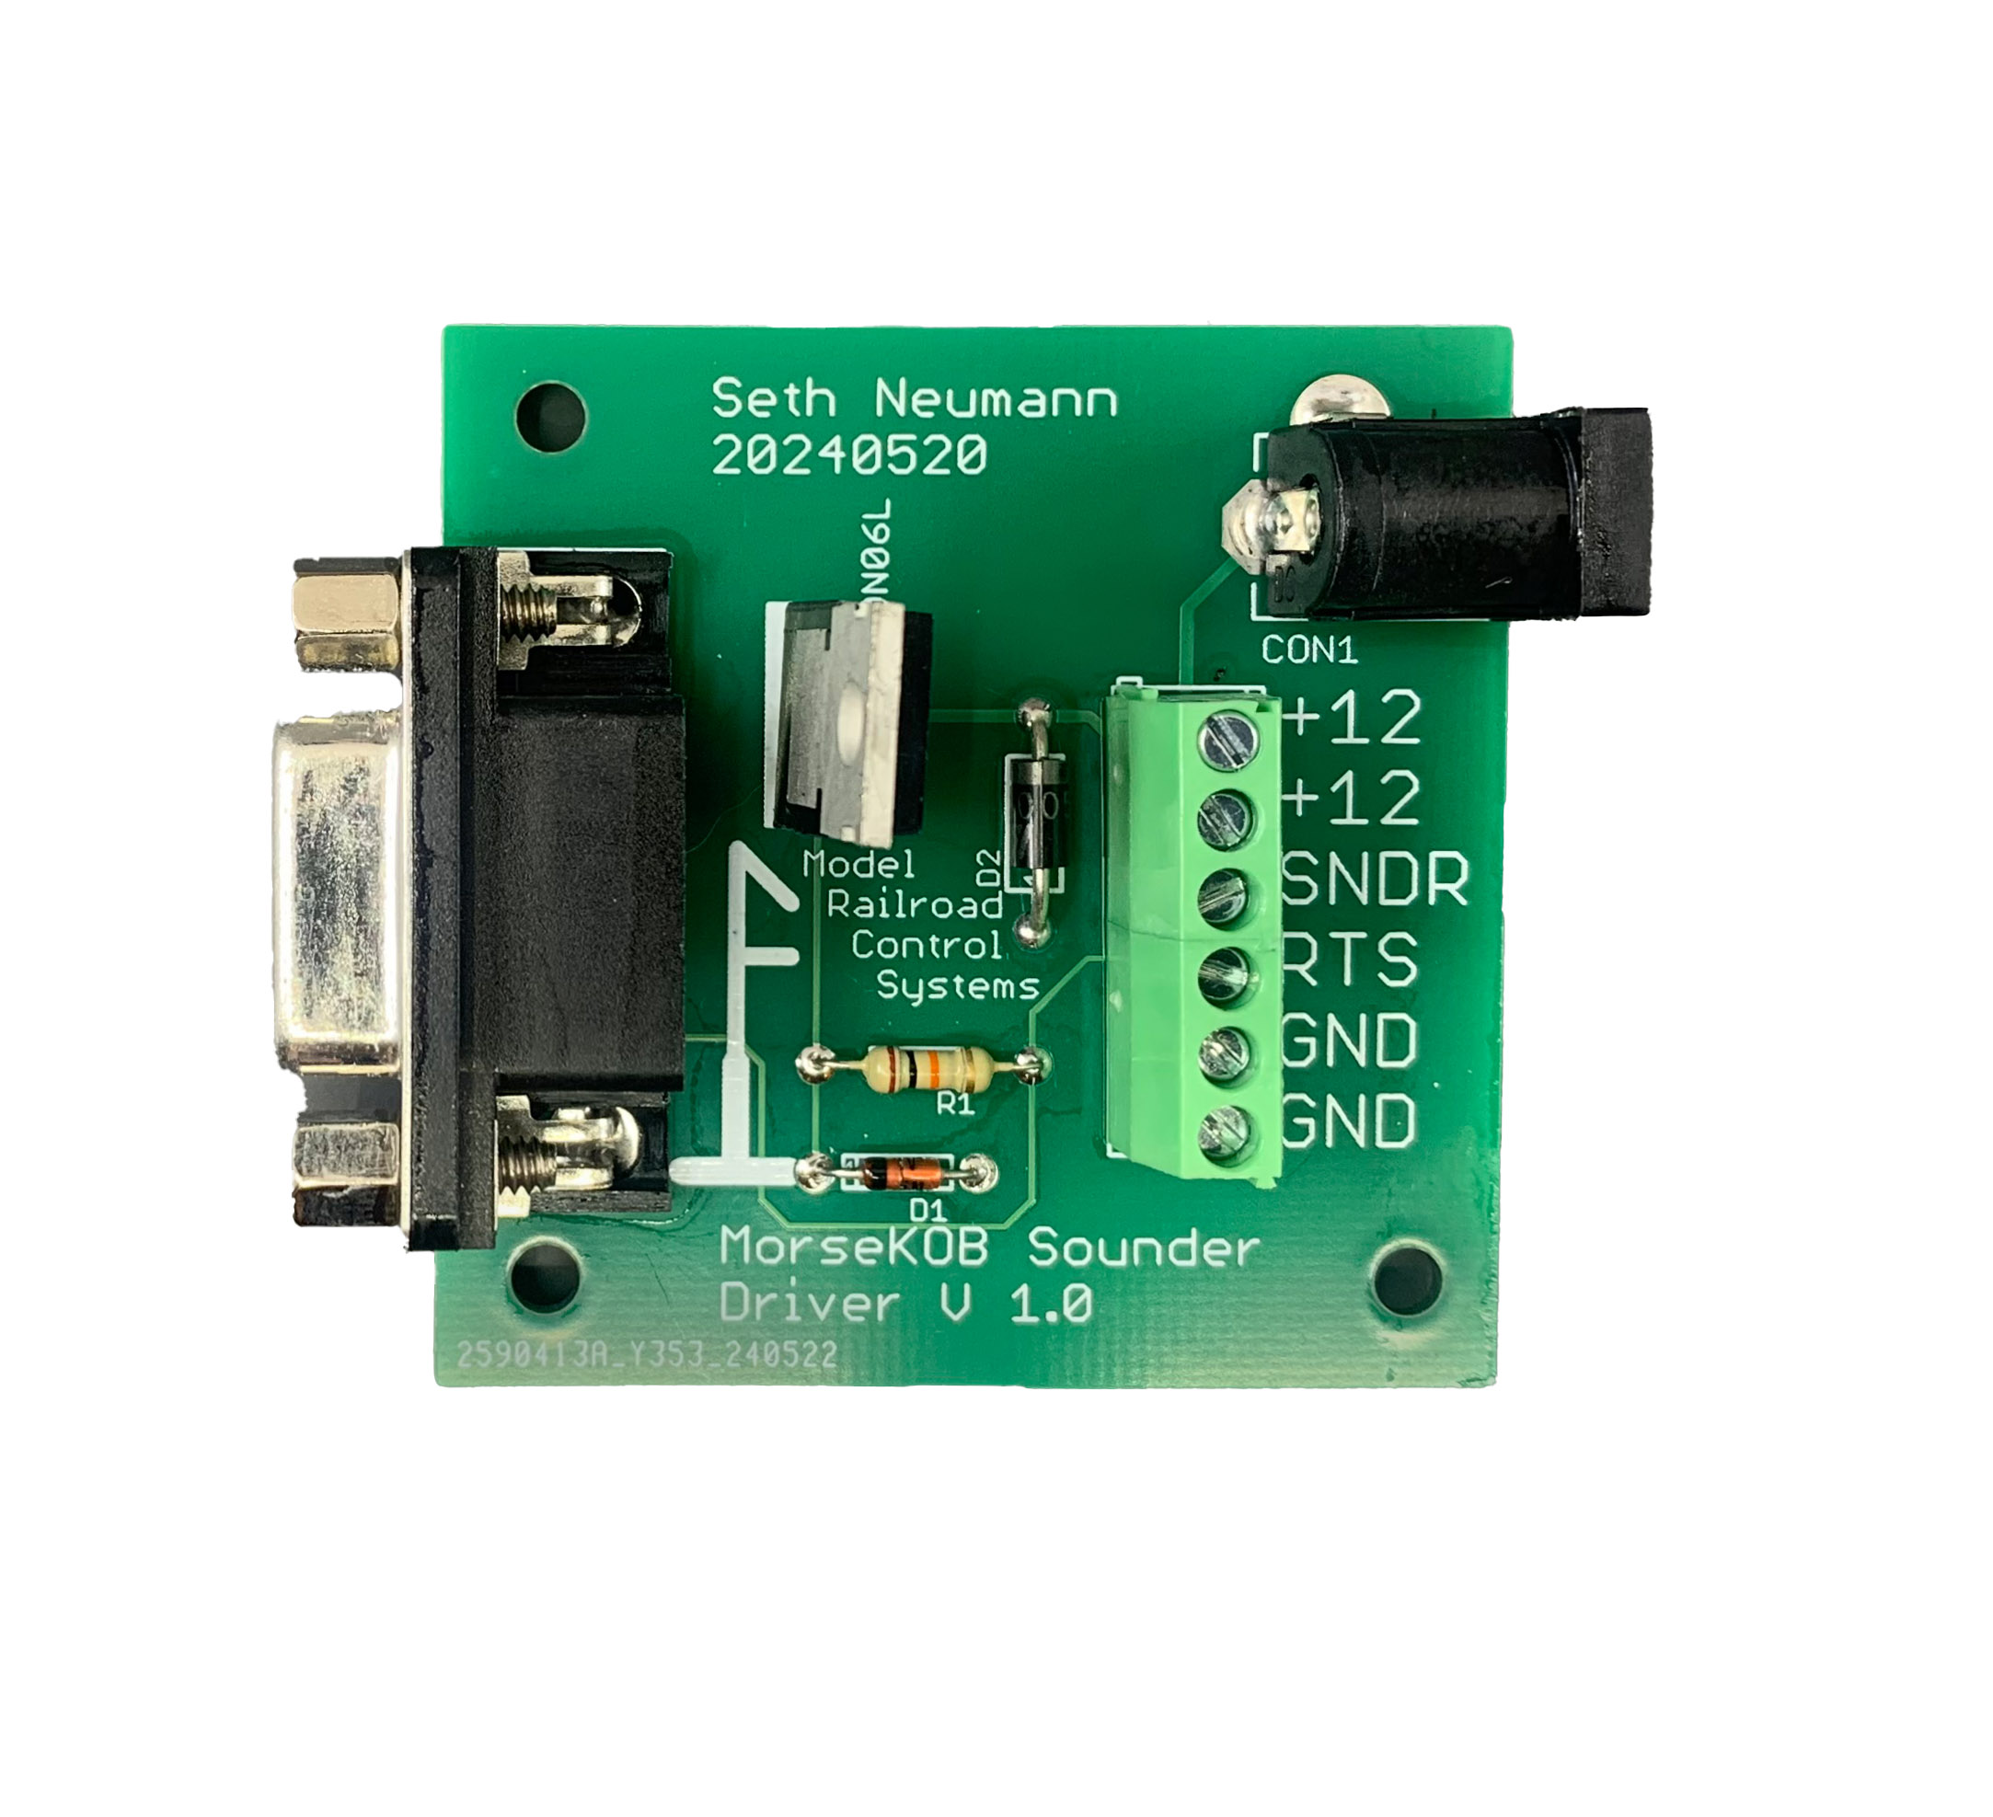

Wall Wart 24V

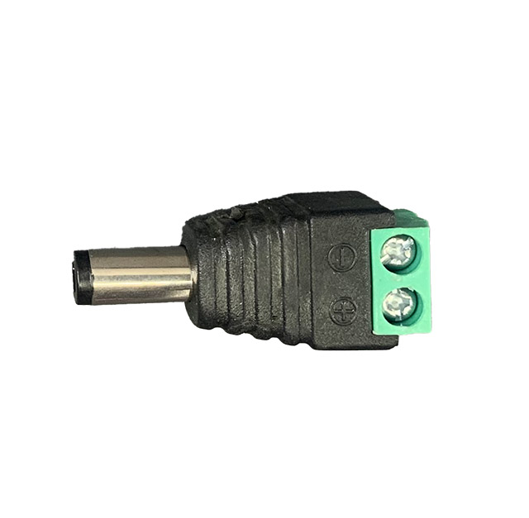

The easiest way to connect is:

1. Plug the male 9 pin end of the dongle into the female connector on the left of the MorseKOB Sounder Driver
2. Connect one terminal of the Sounder to one of the “12V” terminals on the green connecting block
3. Connect the other terminal (blue wire in this diagram) to the “SNDR” terminal on the MorseKOB Sounder Driver.
4. Plug a suitable wall wart with a 2.1mmx5.5mm plug into the “barrel jack” on the upper right of the MorseKOB Sounder Driver. block (note I found mine worked better with a 24V Wall Wart, the board will handle any voltage up to 48VDC) Try the search term “24V wall wart” in your favorite marketplace.
5. Plug your USB dongle into a USB Port on your computer (Morse KOB 3.0 runs on Mac OS and Linux, in addition to Windows)
6. You may want to add a “snubber” across the terminals of the sounder (on the sender, NOT at the Sounder Driver board or the leads will act like a big transmitting antenna. See <https://sites.google.com/site/morsekob/morsekob25/interface?authuser=0#h.83d580pbt4d1>. I like the 1N4005 approach but some people think it makes the sounder release too slowly. Since I can barely hear anyway it doesn't make much difference to me!
7. Configure Morse KOB (see next section)

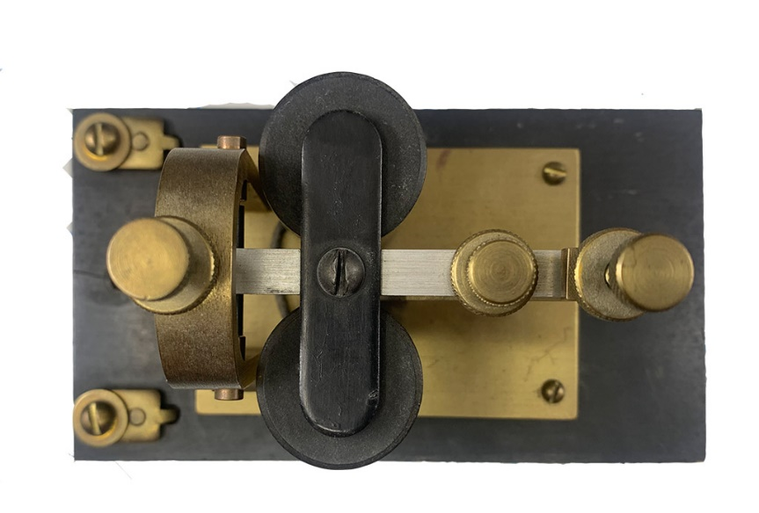

Wall Wart 24V

24VDC Supply, 1A

Ground

Figure 2 - Alternate Connection using Screw Terminals

If you don’t want to use barrel plug (note they are available – see diagram above – with screw terminals) you can connect directly to the MorseKOB Sounder driver. The “12V” terminals are bussed together and the Ground (GND) terminals are bussed together. RTS is also brought to the screw terminal, if you’d prefer to make your own DB9 cable.

## Configuration:

Once you’ve got MorseKOB loaded, you’ll need to set a few things up. These instructions are not exhaustive, so check the MorseKOB documentation, but this worked for me:

Go to FILE/TOOLS/PREFERENCES:

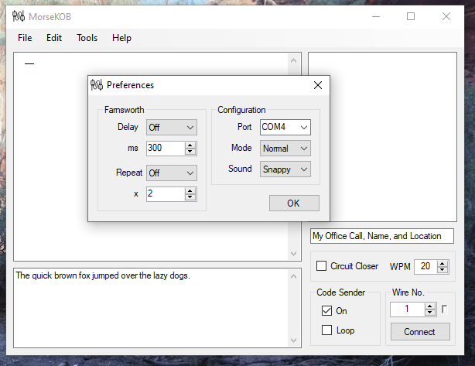

Serial Port of your dongle

Only for computer

Soundsound

Find your Dongle’s serial port (hint: it is almost certainly NOT COM1) and select it under “Configuration.” Mode should be Normal and Sound should be normal, it will play through your computer speakers, so just mute the computer sound when using MorseKOB with your sounder.

Type, paste or open a file, which will appear in the lower left. Click Code Sender On. Leave loop off and circuit closer off.

## Questions:

Check the MorseKOB documentation, especially the tutorial, for hardware issues sales@modelrailroadcontrolsystems.com